My progress so far

## Company Management System – Database Overview

Tables:

1. departments(department_id, department_name)

2. employees(employee_id, name, email, department_id, hire_date, salary, gender, experience_years)

3. projects(project_id, project_name, start_date, end_date, budget, status)

4. employee_project(employee_id, project_id, role)

Highlights:

- Each employee belongs to one department.

- Projects have start/end dates, budgets, and status (active/completed).

- Employees can work on multiple projects with specific roles.

- Additional fields like salary, experience, and gender added for statistical analysis.

- Populated with 10–15 diverse entries in each table for SQL-based exploration.

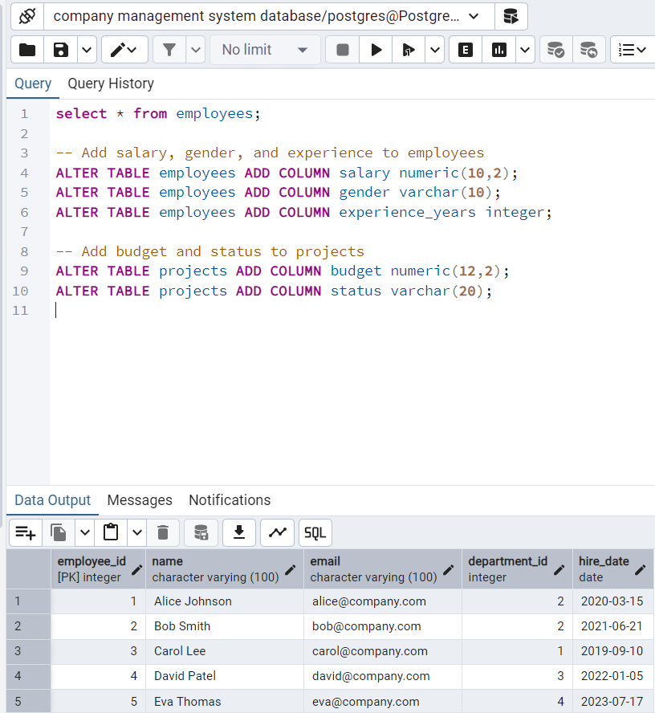

This is was the sample database created for assignment 2, we add more columns to the tables in order for us to do further analysis.

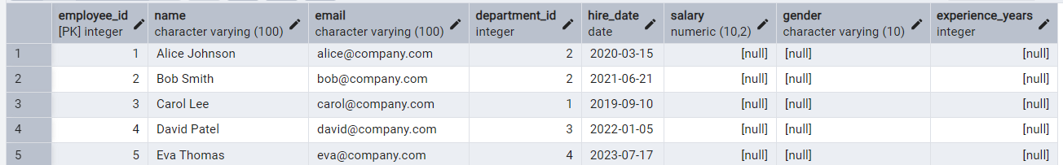

Now the employee table looks like this.

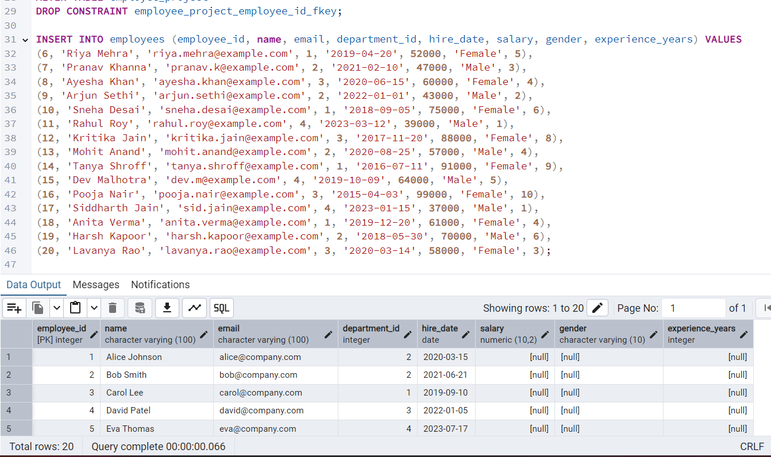

New employees data

Indexing here starts from 6

We add more entries

Our table overview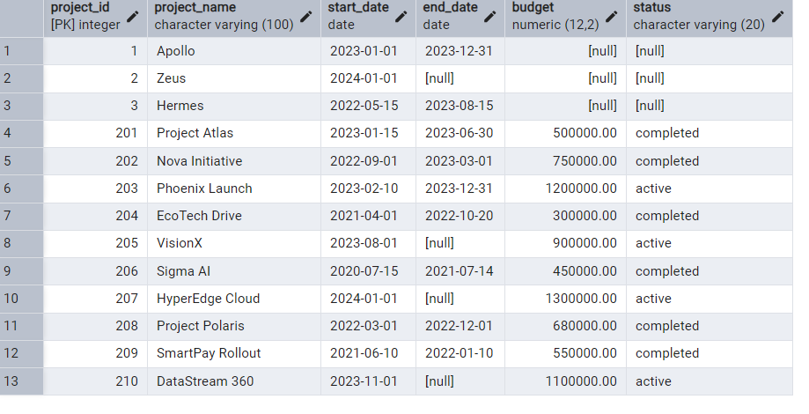

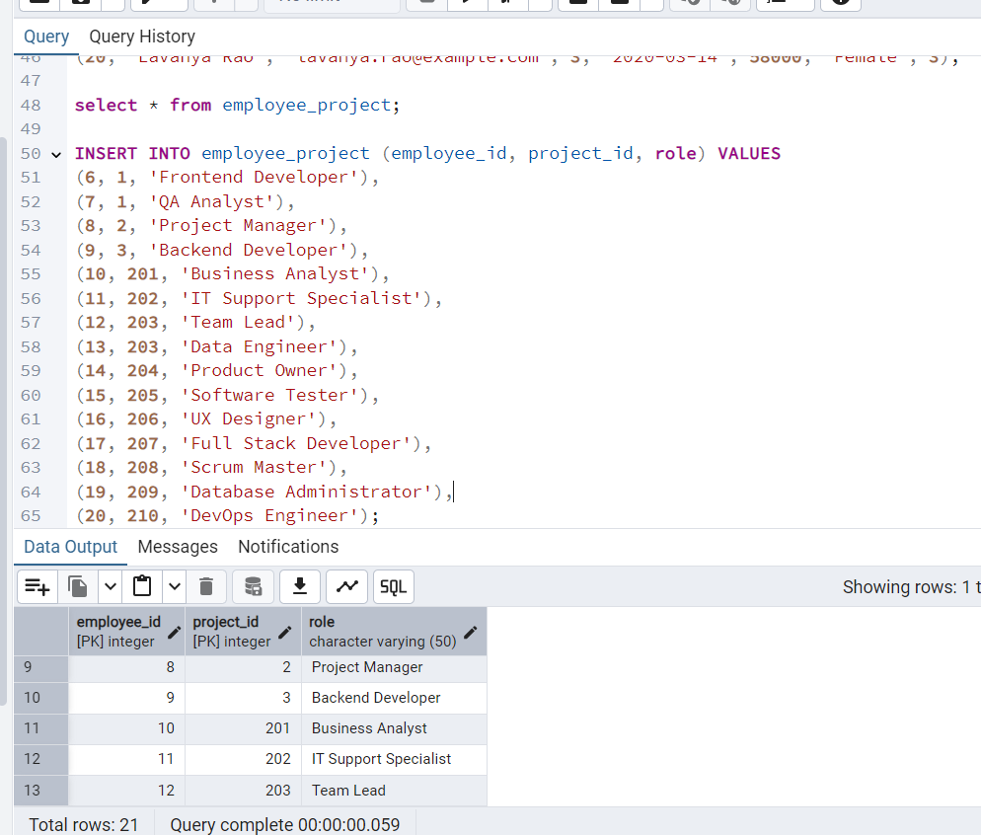new entries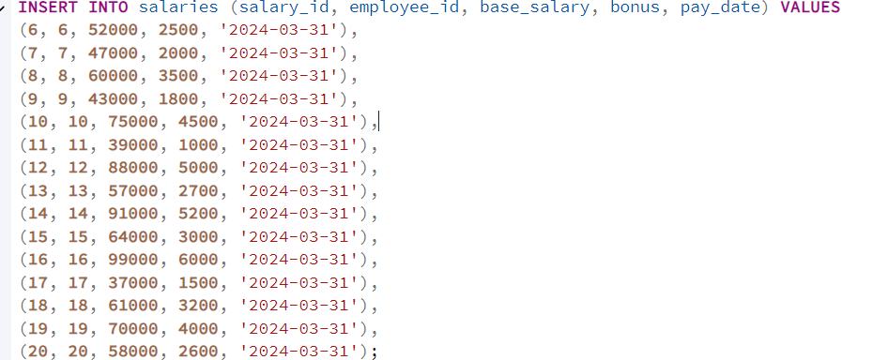

Now that my sample database is ready , let us start the analytics process.

-- 1. Total number of employees

SELECT COUNT(*) AS total_employees FROM employees;

-- Insight: Shows the total workforce size.

-- 2. Salary range overview

SELECT

AVG(salary) AS avg_salary,

MIN(salary) AS min_salary,

MAX(salary) AS max_salary

FROM employees;

-- Insight: Understands overall salary spread and center point.

-- 3. Number of employees by department

SELECT

d.department_name,

COUNT(e.employee_id) AS employee_count

FROM employees e

JOIN departments d ON e.department_id = d.department_id

GROUP BY d.department_name;

-- Insight: Shows departmental size and staffing load.

-- 4. Average salary by department

SELECT

d.department_name,

ROUND(AVG(e.salary), 2) AS avg_salary

FROM employees e

JOIN departments d ON e.department_id = d.department_id

GROUP BY d.department_name;

-- Insight: Compare how departments differ in pay scale.

-- 5. Average experience by gender

SELECT

gender,

ROUND(AVG(experience_years), 2) AS avg_experience

FROM employees

GROUP BY gender;

-- Insight: Measures average experience levels across genders.

-- 6. Employee hiring trend by year

SELECT

EXTRACT(YEAR FROM hire_date) AS hire_year,

COUNT(*) AS hires

FROM employees

GROUP BY hire_year

ORDER BY hire_year;

-- Insight: Reveals hiring momentum and activity over the years.

-- 7. Number of projects assigned to each employee

SELECT

e.name,

COUNT(ep.project_id) AS project_count

FROM employees e

JOIN employee_project ep ON e.employee_id = ep.employee_id

GROUP BY e.name

ORDER BY project_count DESC;

-- Insight: Highlights employee engagement across projects.

-- 8. Project status breakdown

SELECT

status,

COUNT(*) AS total_projects,

ROUND(SUM(budget), 2) AS total_budget

FROM projects

GROUP BY status;

-- Insight: Shows project volume and budget allocation between active and completed.

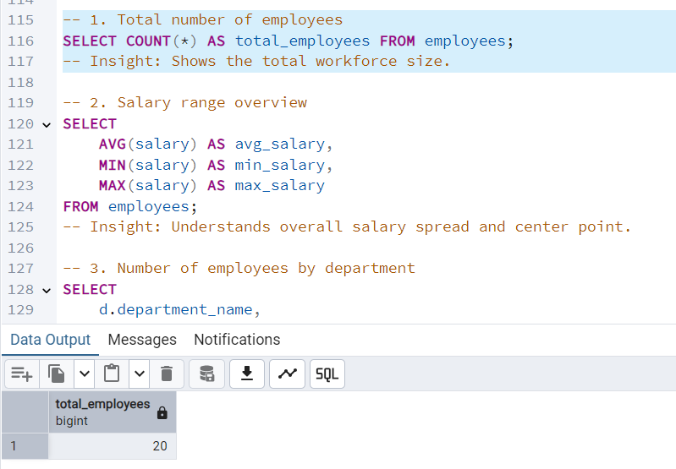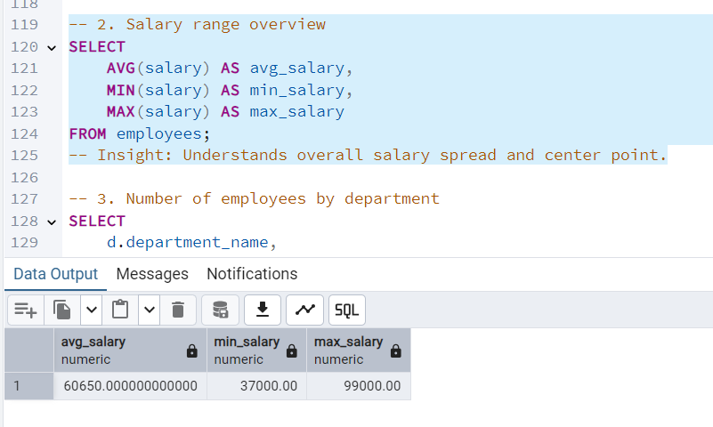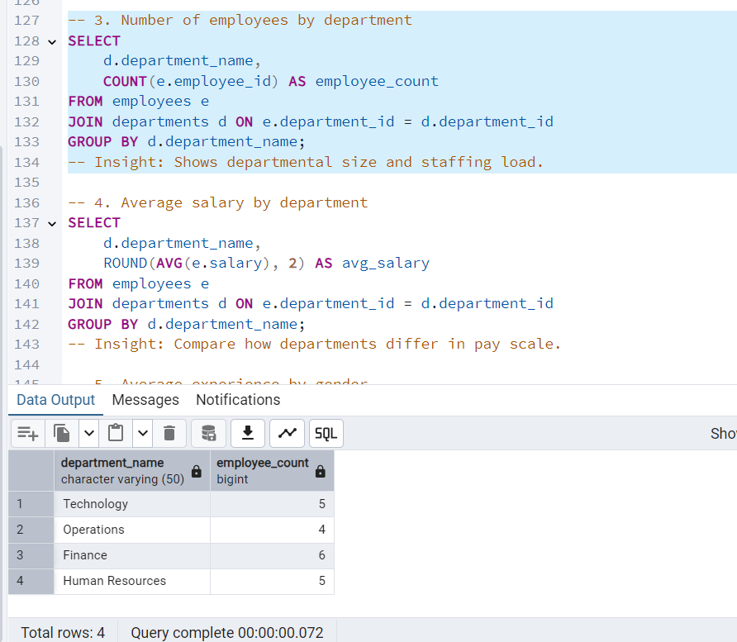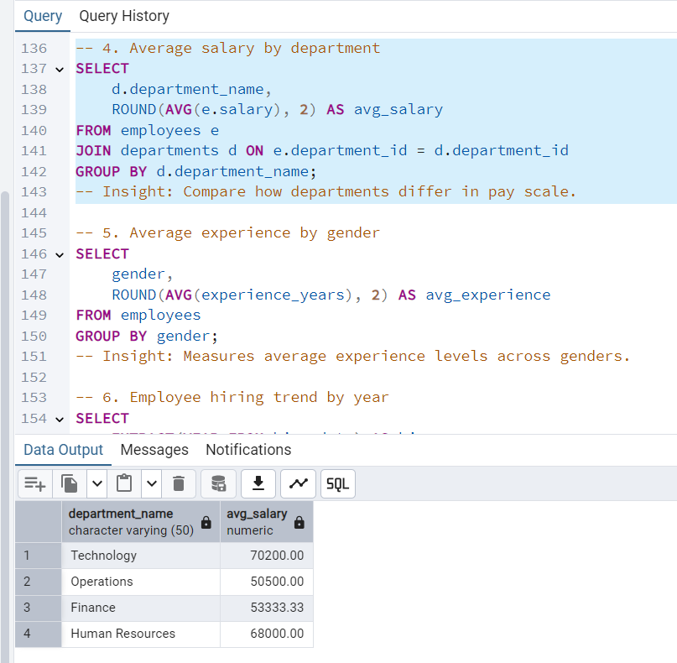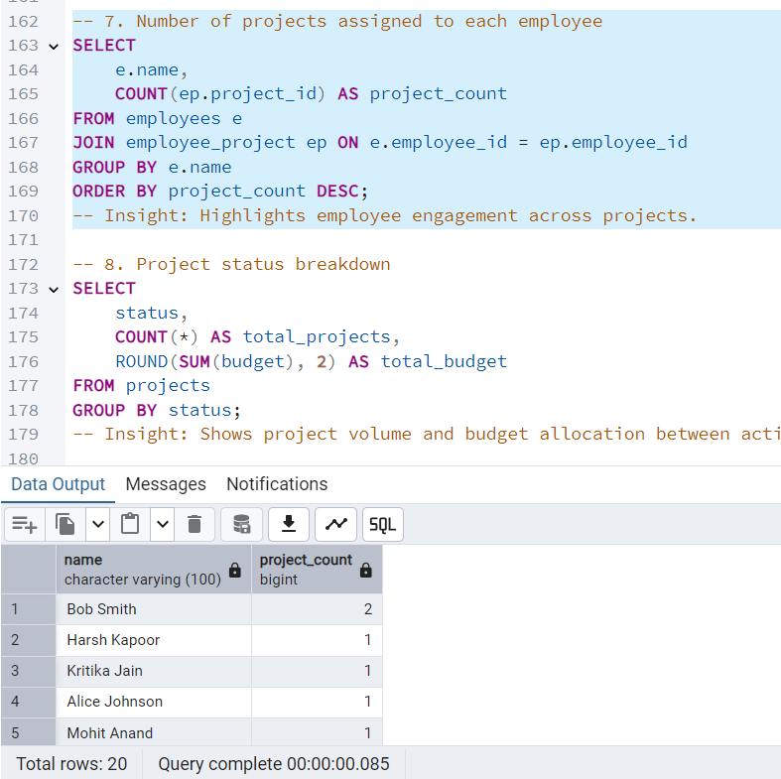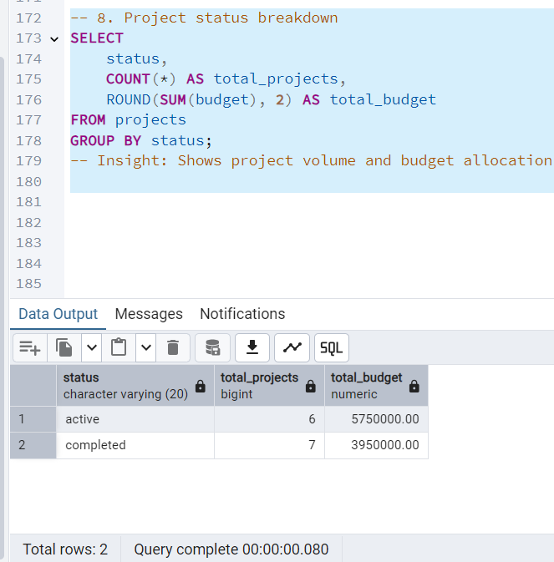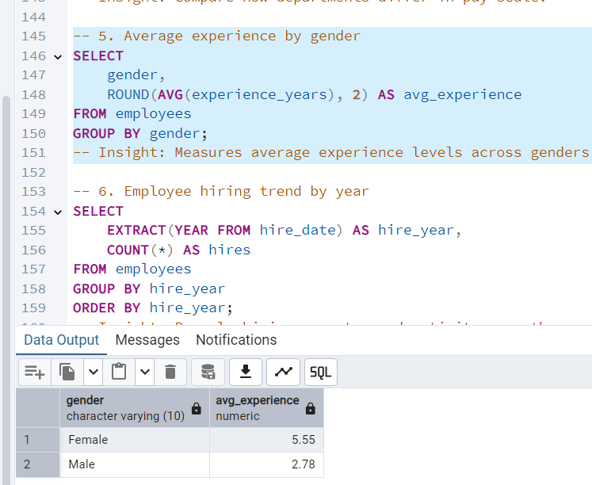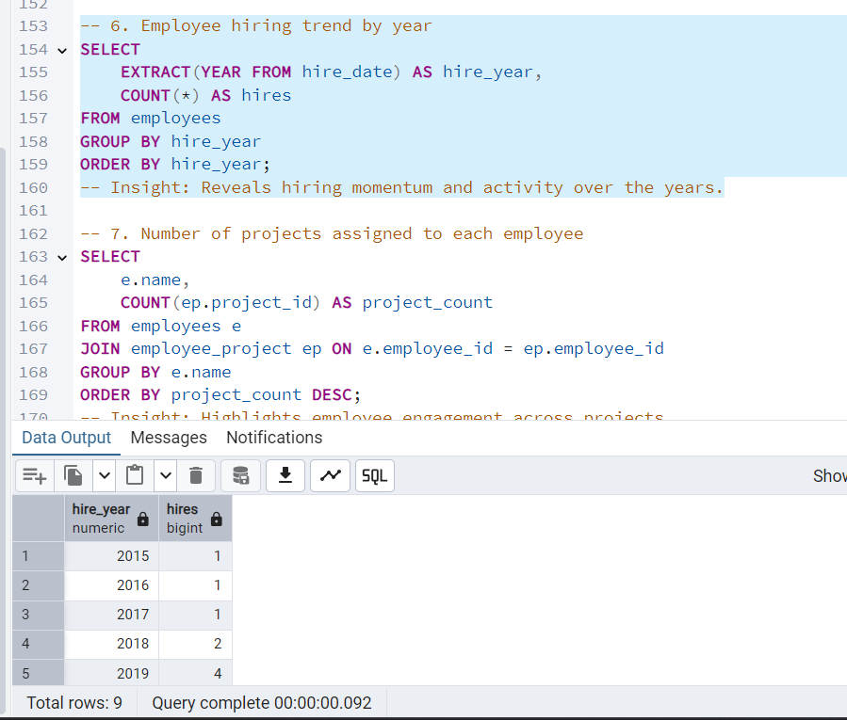



**Final Summary & Conclusion**

This assignment involved the creation, population, and data exploration of a relational database for a Company Management System. The database design followed normalization principles and included key entities such as employees, departments, projects, salaries, and employee-project relationships.

After extending the schema to include additional attributes like salary, experience, and project budget, realistic data was inserted for 20 employees and multiple projects. Referential integrity was maintained throughout by properly managing foreign key constraints.

Using SQL, various exploratory queries were executed to analyze employee distribution, salary trends, hiring activity, and project assignments. Key insights gained include:

* Total number of employees and their distribution across departments
* Average, minimum, and maximum salary across the organization
* Department-wise salary comparison
* Gender-based experience analysis
* Hiring patterns by year
* Employee involvement in projects
* Budget and status breakdown of projects

The assignment successfully demonstrated practical data handling and statistical analysis using SQL. It reinforces the concepts outlined in Course Outcomes CO3 and CO4, specifically focusing on database normalization and the use of SQL for data exploration.

**This concludes Component 3 of the lab assignment.**